Direct Current Circuits Lab
General Purpose: To investigate current, voltage, and resistance relationships in various DC circuits.
Equipment
- DC power supply
- A switch. The switch should be left open when the circuit is not in use for 2 purposes: 1) to prevent the flow of electricity to keep the circuit from heating up. 2) To prevent the components from getting damaged.
- A voltmeter (multimeter) and an ammeter. The voltmeter is used to measure the electrical potential difference between any two points. To use the voltmeter, simply touch the two probes to the various points. If you get a negative voltage, just reverse the two probes. The ammeter measures current. To use the ammeter it must become part of the circuit. DO NOT EXCEED THE MAXIMUM SCALE VALUE. It can damage the meter.
- Resistors: We will use 2 types: 1) a long coil of copper wire. 2) Short ceramic color-coded resistors.
PART A – Ohm’s Law
Purpose
To construct a DC circuit to validate Ohm’s Law: V=IR
Method
- Construct a circuit from the schematic shown.

- Make sure the power is off.
- Connect the red (+) terminal of the power supply to the switch
- Connect the switch to the resistor
- Connect the resistor to the red 50 mA terminal of the ammeter.
- Connect the black (-) terminal of the ammeter to the black terminal of the power supply.
Procedure:
- Select a color-coded resistor for your circuit.

- Use the color-code to determine what the resistance should be and record on the data table.

- Turn on the circuit and adjust the power supply so that the ammeter just barely registers a value. YOU SHOULD NOT TURN THE POWER SUPPLY ABOVE 15 VOLTS AT ANT TIME. FIRE HAZZARD!

- Turn on the multimeter to the DC voltmeter setting. That is the one with the V --- setting.

- Read the current value on the ammeter and touch the voltmeter to either side of the resistor. Record these values on the data table.

- Slightly turn the power supply up to increase the voltage about 1 V. Record the new voltage and current in the data table.

- Repeat step 6 until you reach a maximum voltage of 15 volts. Do not exceed the 15 volts.

- Turn off the circuit.

Remember that the circuit needs to be turned off at the switch at any time the circuit is not in use.

Data Table:
Expected Value of the resistor. __________________________________________
V (volts) | I (mA) | I (A)  Analysis:  Before plotting your data, convert mA to A by dividing by 1000. On graph paper, plot Volts on the y-axis and Amps on the x-axis. The graph should be linear. Draw a best fit line and calculate the slope on the graph. The slope of the line is ∆y/∆x. That equals ∆V/∆I which should equal R if Ohm’s Law is correct.
Questions:
A1. Does your graph support or refute Ohm’s Law? Why?

A2. Determine the percent error. The slope is your experimental value and the color-code is the actual.

A3. Draw two more possible circuit schematics which would allow you to perform this lab. (Hint: the switch, ammeter, and resistor can be placed anywhere as long as the current flows through it.)

A4. What does a transformer do, and explain the difference between a step up and a step down transformer?

A5. What is the difference between AC and DC Current?

PART B – Resistance and Resistivity
Purpose: To verify the equation R = ρL/A where A=πr². This states that the resistance of a conduction wire depends on the material’s resistivity and the dimensions of the wire.
Method:
- Calculate the expected resistance of each of the 4 copper wires using the above equation.
- Set up the circuit as in the Ohm’s Law lab but replace the resistor with the coiled copper wire.
- Turn on the circuit and adjust the power supply where the ammeter reads about 10 mA.
- Record the Amps and Volts from the meters and record.
- Use Ohm’s Law to calculate the measured Resistance.
ρ_{copper} = 1.72 x 10⁻⁸ Ω*m
WIRE # | 1 | 2 | 3 | 4
Length (m)
Gauge
Diameter (mm)
Diameter (m)
Radius (m)

Cross – Sectional Area (m²)
Expected Resistance Ω
Measured Current
(A)
Measured Voltage (V)
Measured Resistance (Ω)
% Difference
% Difference = (R_{e} – R_{m})/(.5(R_{e}+R_{m}))x100
Questions:
B1. What factors could account for the difference between each coil’s expected resistance and its measured resistance? (Think about the wiring in the circuit itself.)

B2. What would be the resistance of a 28 gauge copper wire that is 10 km long?

B3. Define a solenoid. Describe or draw what the magnetic field looks like?
Part C – Series Circuit
Purpose: To investigate the current flow and the voltage drop across several resistors connected in a series.
Method: Obtain 3 different known resistors. These same resistors will be used in for the rest of the labs. Record the values for these resistors. Construct the circuit as shown. Turn on the circuit and set the power supply to 5 V. DO NOT TURN THE POWER SUPPLY DIAL. LEAVE IT AT 5V. Measure the voltage by touching the two probes to each of the designated points. Then, measure the current at each point by making the ammeter PART OF THE CIRCUIT!
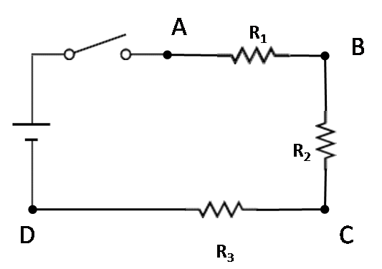

R₁ = ____________________

R₂ = ____________________

R₃ = ____________________

Measured Values: Use the ammeter and voltmeter to measure the V and I at various places. Remember that the ammeter must be part of the circuit.
I_{A} = ______ I_{B} = ______ I_{C} = ______ I_{D} = ______
V_{AB} =______ V_{BC} = ______ V_{CD} = ______
V_{AC} = ______ V_{BD} = ______ V_{AD} = ______
Calculated Values: Use the rules developed in class to calculate what the values should be.
I_{A} = ______ I_{B} = ______ I_{C} = ______ I_{D} = ______
V_{AB} =______ V_{BC} = ______ V_{CD} = ______
V_{AC} = ______ V_{BD} = ______ V_{AD} = ______
Calculations here:
C1: What are the rules for a series circuit?
C2: How do your measured values compare with what you expected? Be Specific! What are some sources of error?
Part D – Parallel Circuit
Purpose: To investigate the current flow and the voltage drop across several resistors connected in parallel.
Method: Obtain 3 different known resistors. These same resistors will be used in for the rest of the labs. Record the values for these resistors. Construct the circuit as shown. Turn on the circuit and set the power supply to 5 V. DO NOT TURN THE POWER SUPPLY DIAL. LEAVE IT AT 5V. Measure the voltage by touching the two probes to each of the designated points. Then, measure the current at each point by making the ammeter PART OF THE CIRCUIT!
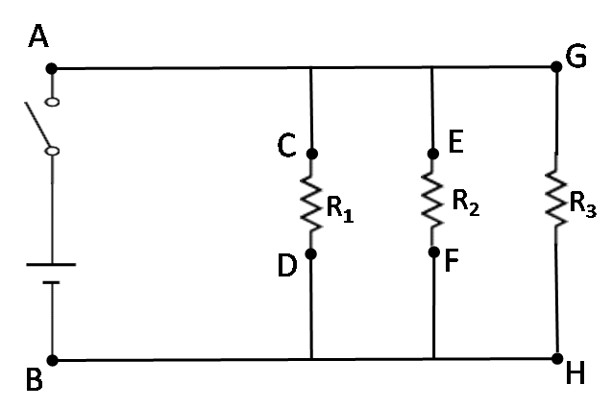

R₁ = ____________________

R₂ = ____________________

R₃ = ____________________

Measured Values: Use the ammeter and voltmeter to measure the V and I at various places. Remember that the ammeter must be part of the circuit.
I_{A} = ______ I_{C} = ______ I_{E} = ______ I_{G} = ______ I_{B} = ______
V_{AB} = ______ V_{CD} = ______ V_{EF} = ______ V_{GH} = ______
V_{AF} = ______ V_{CH} = ______ V_{ED} = ______ V_{GB} = ______
Calculated Values: Use the rules developed in class to calculate what the values should be.
I_{A} = ______ I_{C} = ______ I_{E} = ______ I_{G} = ______ I_{B} = ______
V_{AB} = ______ V_{CD} = ______ V_{EF} = ______ V_{GH} = ______
V_{AF} = ______ V_{CH} = ______ V_{ED} = ______ V_{GB} = ______
Calculations here:
D1: What are the rules for a series circuit?
D2: How do your measured values compare with what you expected? Be Specific! What are some sources of error
Part E – Combination Circuit
Purpose: To investigate the current flow and the voltage drop across several resistors connected in combination.
Method: Obtain 3 different known resistors. These same resistors will be used in for the rest of the labs. Record the values for these resistors. Construct the circuit as shown. Turn on the circuit and set the power supply to 5 V. DO NOT TURN THE POWER SUPPLY DIAL. LEAVE IT AT 5V. Measure the voltage by touching the two probes to each of the designated points. Then, measure the current at each point by making the ammeter PART OF THE CIRCUIT!
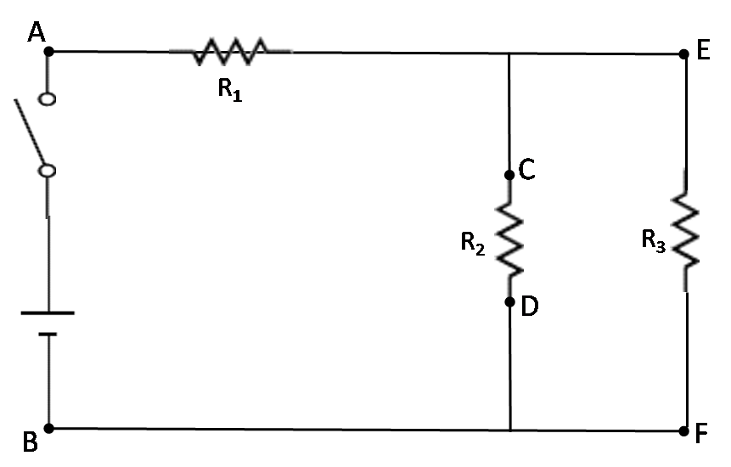

R₁ = ____________________

R₂ = ____________________

R₃ = ____________________

Measured Values: Use the ammeter and voltmeter to measure the V and I at various places. Remember that the ammeter must be part of the circuit.
I_{A} = ______ I_{C} = ______ I_{E} = ______ I_{B} = ______
V_{AC} = ______ V_{CD} = ______ V_{EF} = ______ V_{AF} = ______
V_{ED} = ______ V_{EB} = ______ V_{FB} = ______ V_{AE} = ______
Calculated Values: Use the rules developed in class to calculate what the values should be.
I_{A} = ______ I_{C} = ______ I_{E} = ______ I_{B} = ______
V_{AC} = ______ V_{CD} = ______ V_{EF} = ______ V_{AF} = ______
V_{ED} = ______ V_{EB} = ______ V_{FB} = ______ V_{AE} = ______
Calculations here:
E1: What are the rules for a series circuit?
E2: How do your measured values compare with what you expected? Be Specific! What are some sources of error?

